Question. 01

Question. 01

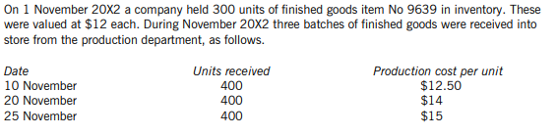

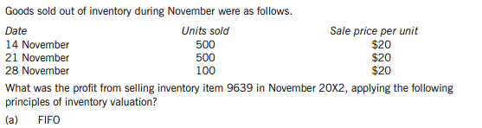(Marks 8)

Question 2

D Company uses a component V22 in its construction process. The company has a demand of 45,000 units per annum. Each unit costs Rs. 4.50. There is no lead time between order and delivery and ordering cost amounts to Rs. 100 per order. The annual cost of holding one unit of inventory is estimated approximately Rs. 0.65. A 0.5% discount is available on orders of at least 3,000 components and 0.75% discount is available if order quantity is 6,000 units or more.

**Required:**

Determine the purchase order quantity of V22 offered by the supplier at which D company’s cost would be minimized.

(Marks 12)